

DIPLOMA IN INFORMATION TECHNOLOGY

COURSEWORK 2

Subject: JAVA PROGRAMMING
Subject code: DIT1323

DEADLINE:

Question No. | Week No. | ()
1 | 6
2 | 9

GROUP MEMBERS & CONTRIBUTION:

Student ID | Student Name | Program Listing (P) or  Design (DS) or Documentation (DC)
24052128 | Babayev Annageldi | Code, Flowchart,Report
24135931 | ------------- | Code,Flowchart

SDS ACADEMIC INTEGRITY STATEMENT

Sunway Diploma Studies is committed to the principles of academic integrity. Academic integrity means placing five fundamental values: honesty, trust, fairness, respect, and responsibility into practice. It is being honest in the academic work you do at the programme/college, being fair to others, and taking responsibility for learning, and acting in an ethical manner in all your academic endeavours. We believe that these five values are truly foundational to the programme.

We hereby declare that:
- We fully understand and will uphold the academic integrity of Sunway Diploma Studies (SDS).
- We confirm that the work hereby submitted is my own original work and where other people’s work has been used this has been fully acknowledged.
- We are aware of the importance of conducting exams with integrity and fairness, and we hereby confirm that we will comply with the requirements.
- We are aware that non-compliance with these instructions and unfair conduct constitute a disciplinary offense, and actions will be taken including but not limited to being expelled.

No | Name | Signature | Date
1 | Babayev Annageldi | Anna | 26.09.2025
2 | Madadaev Bordjali | Ali | 26.09.2025

INSTRUCTIONS TO CANDIDATES
This assignment will contribute 35% to your final grade.
This is a group assignment.

Learning Outcome
LO1: Build short Java programs.
LO2: Apply Java programming concepts and techniques in problem-solving.
LO3: Build robust application using Java’s object-oriented features.

Coursework 2: Presentation (35%)

You are required to present and demonstrate your practical exercises by developing a portfolio using the JAVA programming language with Apache NetBeans IDE. The portfolio should include the following aspects: -
- Program Codes with comments
- Programs’ screenshots
- Design work (Flowchart for Q1 and UML class diagram for Q2)

The following are the pieces of practical exercise (Appendix A) that need to be included in the portfolio: -
Q1. Elementary Programming / Selection / Repetition
Q2. Arrays / Classes and Objects

Assessment Criteria
You will be assessed based on the following requirements:
REQUIREMENTS | MARKS
Portfolio  - Elementary Programming / Selection / Repetition (50 marks)  - Arrays / Classes and Objects (50 marks) | 100

Mode of Submission
- The assignment must be submitted in softcopy – portfolio (.docx or .pdf file) and source code (.java file(s)). Both must be attached. Ensure that the files do not contain any malicious programs.
- The report must use Times New Roman, 12 pt. standard and 1.5 lines spacing.
- All codes must use Courier New, 9 pt. standard with single lines spacing.

Date of Submission
The submission dates are stated in page 1. All submission must be done through e-Learn. As a general rule, no extension of time will be allowed.
Appendix A

Q1. Elementary Programming / Selection / Repetition
Write a Java application that prompts the user to input the cosmetic product type (e.g., Lipstick, Foundation, or Perfume) and the quantity, then calculates the total bill. The product prices are as follows:
Product Type | Price (MYR)
Lipstick | 45
Foundation | 80
Perfume | 150
A special discount will be applied based on the total number of products purchased. The discount scheme is as follows:
Quantity | Discount (%)
1–2 | 0%
3–6 | 15%
>6 | 20%
All members are subjected to additional 5% discount. Your program should obtain the necessary input from the user, display the calculated total bill (including 8% sales & service tax), and apply any applicable discounts. You may choose either a command-line interface (CLI) or a graphical user interface (GUI) for input and output. All user inputs must be validated before proceeding with the calculations.

Java Code:

import java.util.Scanner;
/**
* A program to calculate the total bill for cosmetic products, applying discounts and tax.
* @author Annageldi, Bordjali
* @version 1.0
*/
public class CosmeticBill {

public static void main(String[] args) {

Scanner input = new Scanner(System.in);

// Product prices
final double LIPSTICK_PRICE = 45.0;
final double FOUNDATION_PRICE = 80.0;
final double PERFUME_PRICE = 150.0;

// Input product type
System.out.println("Available products: Lipstick Foundation, Perfume");
System.out.print("Enter product type: ");

String productType = input.nextLine().trim().toLowerCase();

// Validate product type and get price
double price;
switch (productType) {
case "lipstick":
price = LIPSTICK_PRICE;
break;
case "foundation":
price = FOUNDATION_PRICE;
break;
case "perfume":
price = PERFUME_PRICE;
break;
default:
System.out.println("Error: Invalid product type.");
return; // Exit program if input is invalid
}

// Input quantity
System.out.print("Enter quantity: ");
int quantity = input.nextInt();
if (quantity <= 0) {
System.out.println("Error: Quantity must be positive.");
return; // Exit program if input is invalid
}

// Input membership status
System.out.print("Are you a member? (yes/no): ");
String isMember = input.next().trim().toLowerCase();
boolean memberDiscount = isMember.equals("yes");

// Calculate total cost before discounts
double totalCost = price * quantity;

// Apply quantity-based discount
double discountRate = 0.0;
if (quantity >= 3 && quantity <= 6) {
discountRate = 0.15;
} else if (quantity > 6) {
discountRate = 0.20;
}

double discountAmount = totalCost * discountRate;
double costAfterDiscount = totalCost - discountAmount;

// Apply additional 5% member discount if applicable
if (memberDiscount) {
double memberDiscountAmount = costAfterDiscount * 0.05;
costAfterDiscount -= memberDiscountAmount;
}

// Calculate 8% Sales and Service Tax
double tax = costAfterDiscount * 0.08;
double finalBill = costAfterDiscount + tax;

// Display the bill
System.out.println("\n=== FINAL BILL ===");
System.out.printf("Product: %s%n", productType);
System.out.printf("Quantity: %d%n", quantity);
System.out.printf("Unit Price: MYR %.2f%n", price);
System.out.printf("Total before discounts: MYR %.2f%n", totalCost);
if (discountRate > 0) {
System.out.printf("Quantity Discount (%d%%): MYR -%.2f%n", (int)(discountRate * 100), discountAmount);
}
if (memberDiscount) {
System.out.printf("Member Discount (5%%): MYR -%.2f%n", costAfterDiscount * 0.05);
}
System.out.printf("Price after discounts: MYR %.2f%n", costAfterDiscount);
System.out.printf("Sales & Service Tax (8%%): MYR %.2f%n", tax);
System.out.printf("TOTAL AMOUNT DUE: MYR %.2f%n", finalBill);

input.close(); // Close the scanner
}
}

Output:
1.
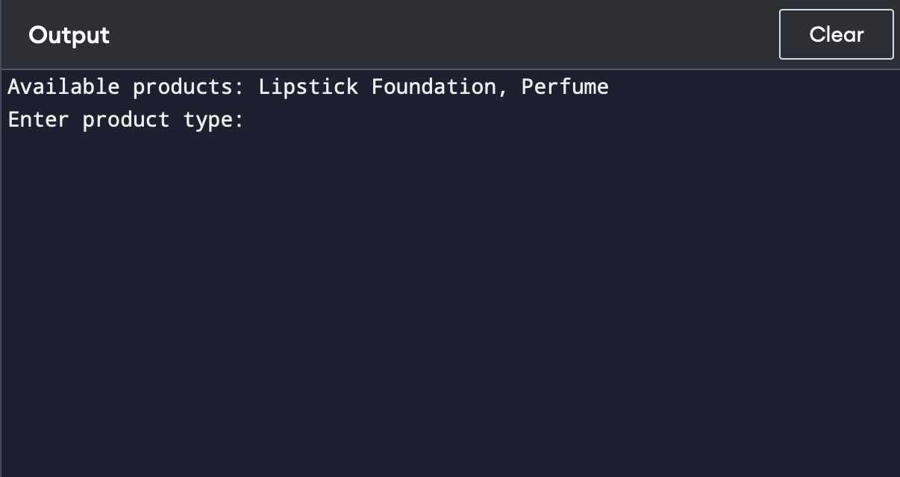

2.
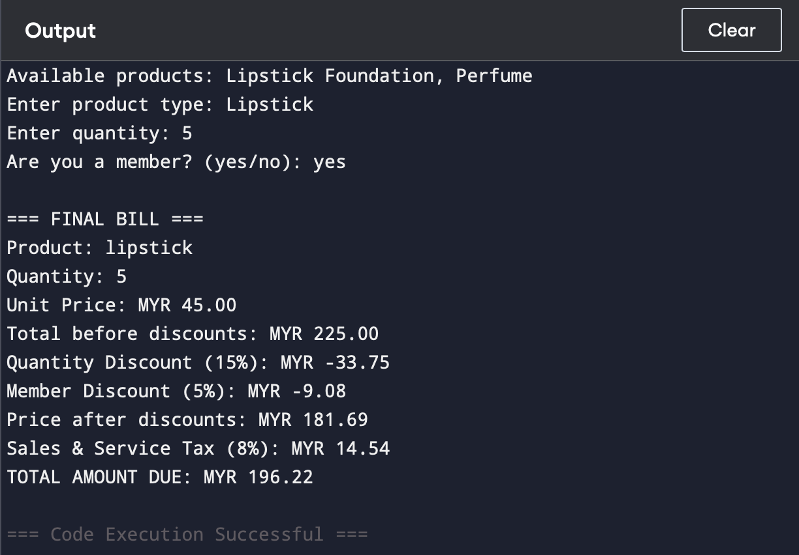
Flowchart: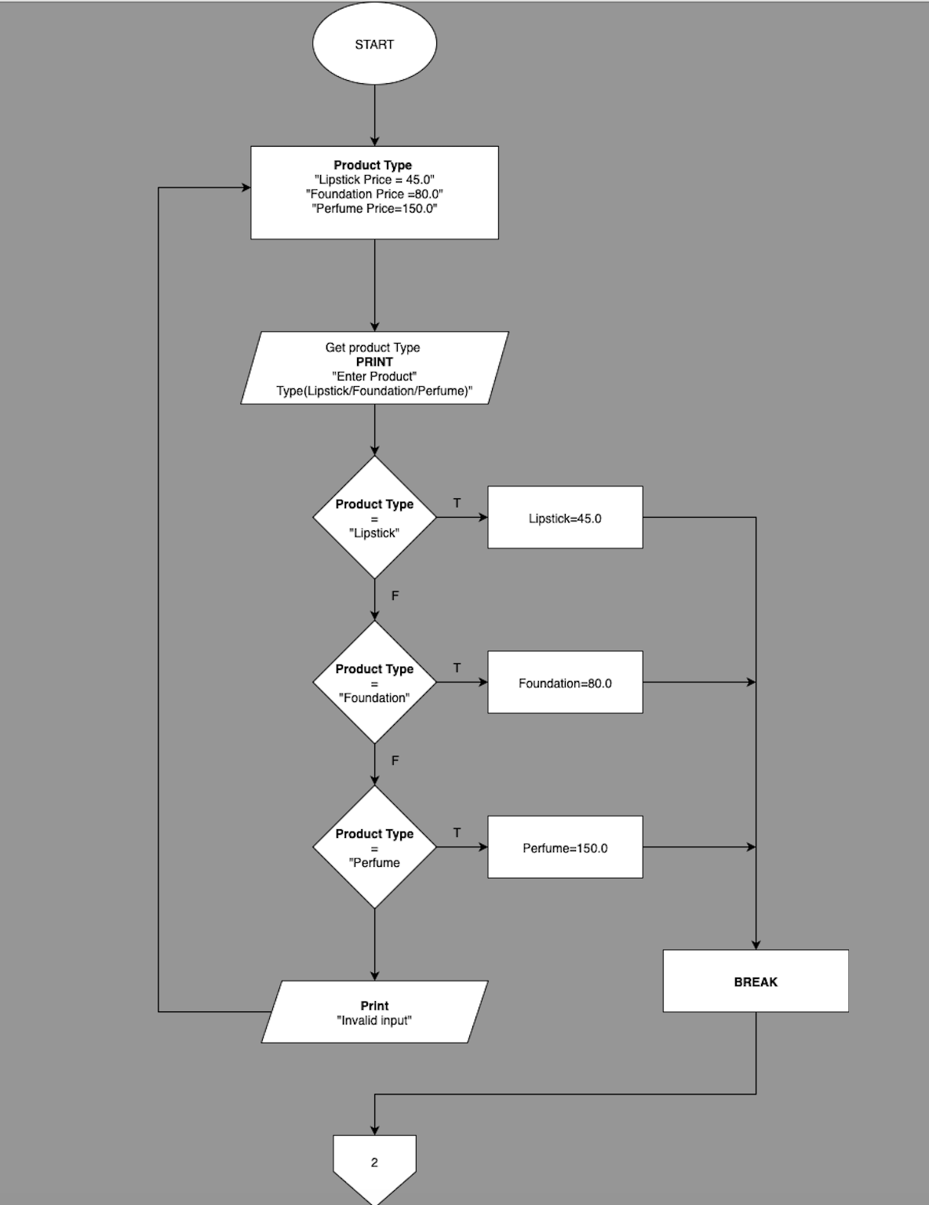:

2.
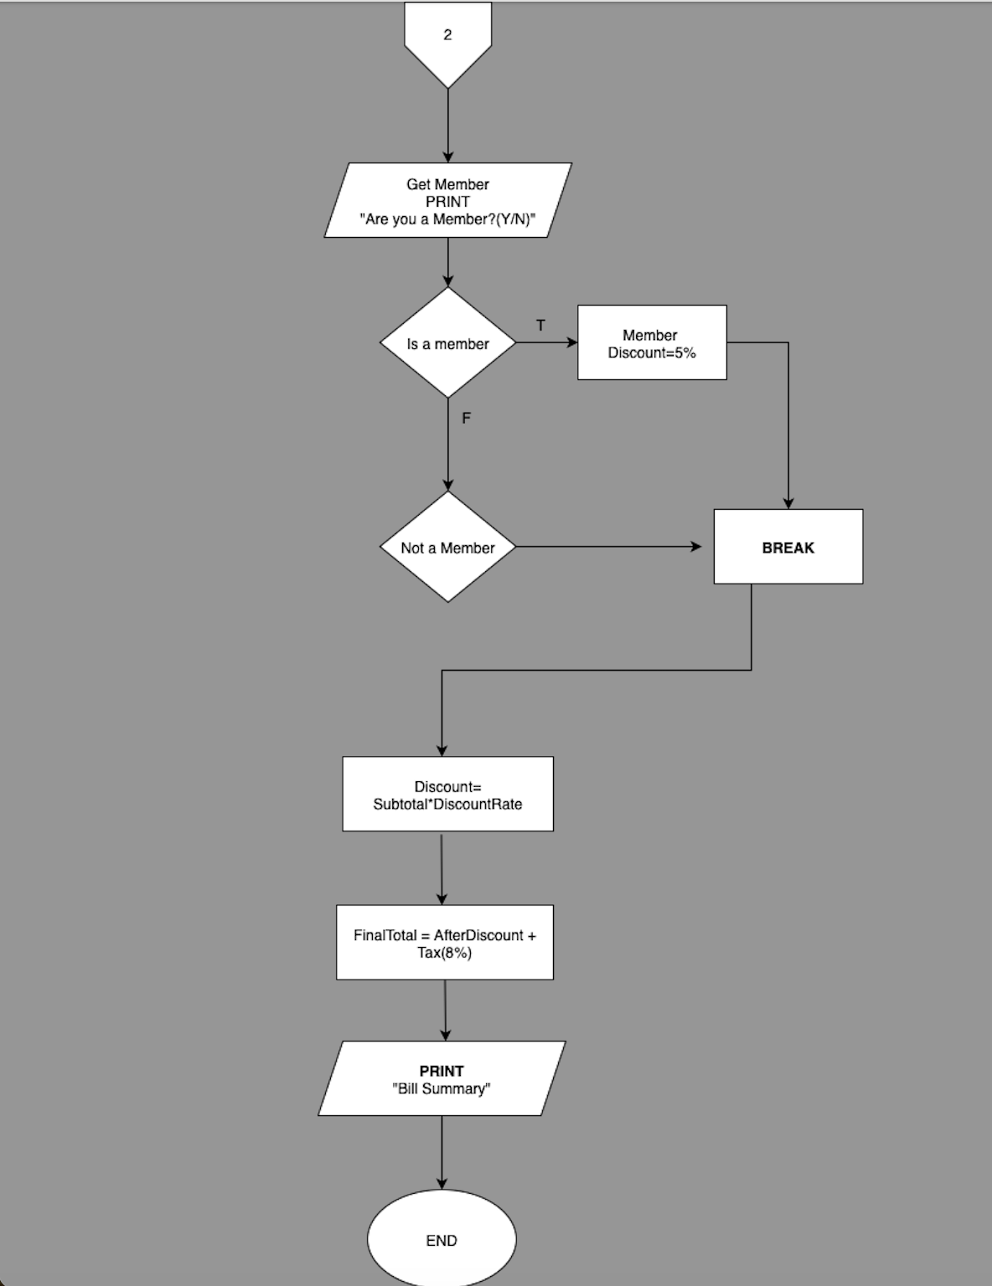

3.
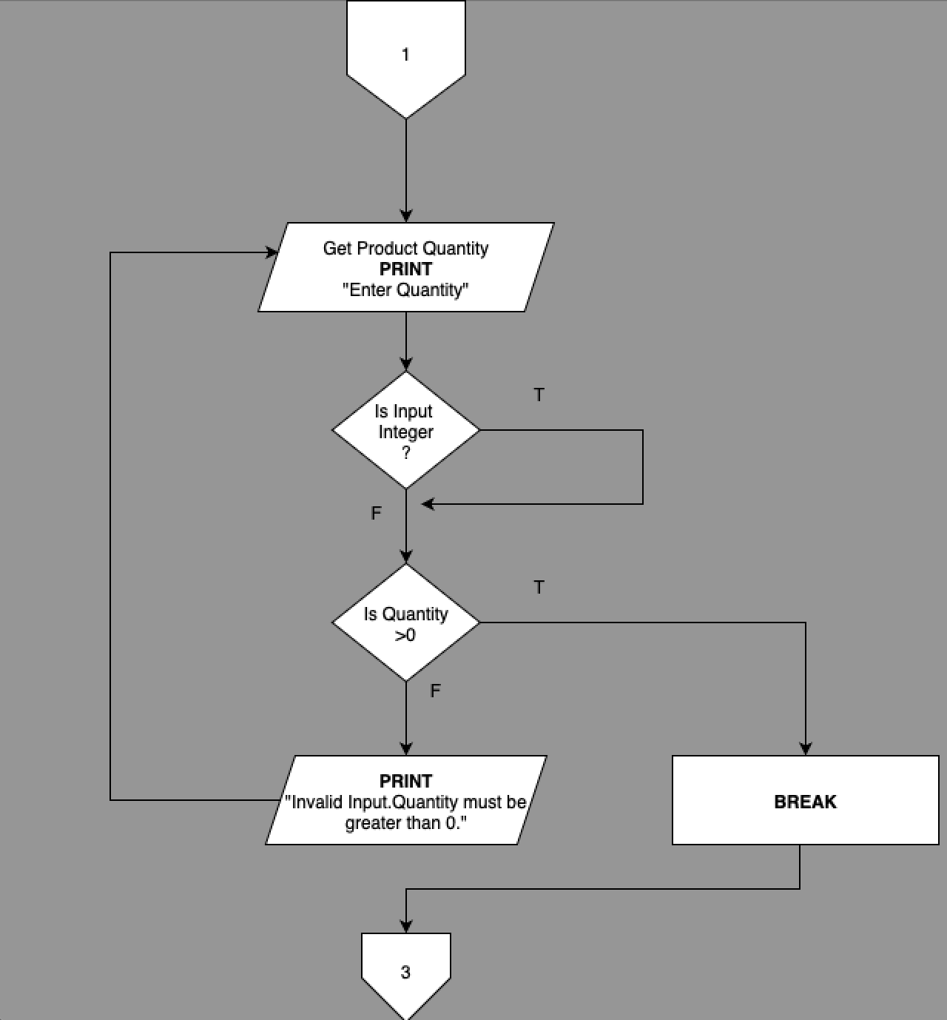

(50 marks)

Q2. Arrays / Classes and objects
Create a Java class called ExperimentRecord that stores experimental observation data for a student. Each ExperimentRecord object contains data fields such as the student’s name, ID, and temperature readings recorded over five consecutive days (stored in a one-dimensional array). The class should include necessary methods to store and retrieve data, as well as three additional methods:
- Find the maximum temperature.
- Find the minimum temperature.
- Calculate the average daily temperature.
- Determine the experiment status based on the average temperature using the following criteria:

Average Temperature (°C) | Experiment Status
37.5 and above | High Temperature Alert
35.0 – 37.4 | Normal Range
Below 35.0 | Below Expected Level
Additionally, the class should contain a toString() method to display the student’s experiment details. You must write a driver class to test program to verify the ExperimentRecord class by obtaining the necessary input from the user, computing the total temperature, average temperature, and experiment status, and finally displaying the student’s experiment report. All temperature readings should be validated before being stored in the object.
(50 marks)

Java Code:

/**

* @author Annageldi
* @version 1.0
*/
public class ExperimentRecord {
// Data fields
private String studentName;
private String studentID;
private double[] temperatureReadings; // Array to store 5 daily temperatures

public ExperimentRecord(String name, String id, double[] temperatures) {
this.studentName = name;
this.studentID = id;
// Validate that exactly 5 temperatures are provided
if (temperatures.length != 5) {
throw new IllegalArgumentException("Must provide exactly 5 temperature readings.");
}
this.temperatureReadings = temperatures.clone(); // Copy the array
}

// Getter methods
public String getStudentName() { return studentName; }
public String getStudentID() { return studentID; }
public double[] getTemperatureReadings() { return temperatureReadings.clone(); }

/**
* Finds and returns the maximum temperature from the readings.
* @return The maximum temperature
*/
public double findMaxTemperature() {
double max = temperatureReadings[0];
for (int i = 1; i < temperatureReadings.length; i++) {
if (temperatureReadings[i] > max) {
max = temperatureReadings[i];
}
}
return max;
}

/**
* Finds and returns the minimum temperature from the readings.
*/
public double findMinTemperature() {
double min = temperatureReadings[0];
for (int i = 1; i < temperatureReadings.length; i++) {
if (temperatureReadings[i] < min) {
min = temperatureReadings[i];
}
}
return min;
}

/**
* Calculates and returns the average temperature.
* @return The average temperature
*/
public double calculateAverageTemperature() {
double sum = 0;
for (double temp : temperatureReadings) {
sum += temp;
}
return sum / temperatureReadings.length;
}

/**
* Determines the experiment status based on the average temperature.
* @return The experiment status as a String
*/
public String determineExperimentStatus() {
double avg = calculateAverageTemperature();
if (avg >= 37.5) {
return "High Temperature Alert";
} else if (avg >= 35.0) {
return "Normal Range";
} else {
return "Below Expected Level";
}
}

/**
* Returns a string representation of the student's experiment details.
* @return Formatted string with all experiment data and analysis
*/
@Override
public String toString() {
return String.format(
"Student Name: %s%n" +
"Student ID: %s%n" +
"Temperature Readings: %.1f, %.1f, %.1f, %.1f, %.1f%n" +
"Maximum Temperature: %.1f°C%n" +
"Minimum Temperature: %.1f°C%n" +
"Average Temperature: %.1f°C%n" +
"Experiment Status: %s%n",
studentName, studentID,
temperatureReadings[0], temperatureReadings[1], temperatureReadings[2],
temperatureReadings[3], temperatureReadings[4],
findMaxTemperature(), findMinTemperature(),
calculateAverageTemperature(), determineExperimentStatus()
);
}
}

import java.util.Scanner;

/**
* A driver class to test the ExperimentRecord class by taking user input,
* creating an object, and displaying the experiment report.
* @author Student Name
* @version 1.0
*/
public class ExperimentDriver {

public static void main(String[] args) {
Scanner input = new Scanner(System.in);

// Get student details
System.out.print("Enter student name: ");
String name = input.nextLine();

System.out.print("Enter student ID: ");
String id = input.nextLine();

// Get temperature readings for 5 days
double[] temperatures = new double[5];
System.out.println("Enter temperature readings for 5 consecutive days:");

for (int i = 0; i < 5; i++) {
while (true) {
System.out.printf("Day %d temperature (°C): ", i + 1);
if (input.hasNextDouble()) {
double temp = input.nextDouble();
// Basic validation: temperature should be a reasonable value
if (temp >= 0 && temp <= 50) {
temperatures[i] = temp;
break;
} else {
System.out.println("Error: Please enter a realistic temperature between 0 and 50.");
}
} else {
System.out.println("Error: Please enter a valid number.");
input.next(); // Clear the invalid input
}
}
}

// Create ExperimentRecord object
ExperimentRecord record = new ExperimentRecord(name, id, temperatures);

// Display the experiment report
System.out.println("\n=== EXPERIMENT REPORT ===");
System.out.println(record.toString()); // Uses the overridden toString() method

input.close();
}
}

Flowchart:

[Total: 100 marks]

MARKING SCHEME FOR PORTFOLIO

Question 1

Criteria | Exceeds | Moderate | Poor | Marks
 | 15-20 marks | 8-14 marks | 0-7 marks
Program Listing  (20%)  Elementary Programming | - Bug frees program  - Excellent in program logic  - Accurate variables and the data types  - Excellent input and output which promotes user-friendliness  - Adequate mathematic formulas used in calculation  - Adequate used of selection structure  - Adequate used of repetition structure | - Relatively bug frees program with minor logic issues.  - Suitable variables and the data types; improper data type used for some cases and/or might contain unnecessary variables  - Sufficient input and output but maybe not user-friendly  - Suitable mathematic formulas used in calculation or might contain minor errors  - Ability to use selection structure; might have minor errors in condition setting.  - Ability to use repetition structure; might have minor errors in condition setting. | - Major bugs. Program contain limited logic.  - Inadequate used of variables as well as data types  - Inadequate used of mathematical formula  - Insufficient input and output and not user-friendly  - Inadequate used of selection structure  - Inadequate used of repetition structure
 | 21-30 marks | 11-20 marks | 0-10 marks
Design and  Documentation  (30%)  Flowchart  Documentation and comments | - Excellent design, with a high level of logic that covers all basic requirements.  - Hardly any errors in the design in terms of symbols used or the logic of the solution.  - Excellent mapping between the design and the coding.  - All elements are presented in a clear and organized manner.  - Useful comments that elaborate the meaning of a statement or a block of statements and are placed in a proper manner without being overwhelming. | - Design has a moderate level of logic and covers most of the basic requirements.  - Some errors in the design in terms of symbols used or logic of solution.  - Moderate mapping with the coding is.  - Majority of elements are presented.  - A few comments to elaborate the meaning of a statement or a block of statements, and they are not placed in a proper manner. | - Design is very basic, with little logic and only partially covering very basic requirements.  - Many essential elements are missing.  - Very little comments or no comments included to explain the meaning of a statement or a block of statements, and they are not placed in a useful manner.
Comments |  |  | Total (50%)

Question 2

Criteria | Exceeds | Moderate | Poor | Marks
 | 15-20 marks | 8-14 marks | 0-7 marks
Program Listing  (20%)  Array  Classes and Objects | - Bug frees program.  - Excellent in program logic with appropriate method definition and method called.  - Excellent use of array and manipulation of array.  - Excellent in program logic with appropriate class constructs and object instantiation.  - Excellent in program logic with appropriate method definition and method called.  - Excellent input and output which promotes user-friendliness | - Bug frees program. Contains executable code with minor logic issues.  - Adequate ability in using and manipulating array.  - Ability to construct class and instantiates object; might have minor errors in class constructs.  - Ability to use method definition and method called; might have minor errors in parameter(s) and/or return type.  - Sufficient input and output but maybe not user-friendly | - Major bugs. Program contain limited logic.  - Unable to use and manipulate array.  - Unable to construct class and instantiates object.  - Unable to define and used the method.  - Insufficient input and output and not user-friendly
 | 21-30 marks | 11-20 marks | 0-10 marks
Design and  Documentation  (30%)  Class diagram  Documentation and comments | - Excellent design, with a high level of logic that covers all basic requirements.  - Hardly any errors in the design in terms of symbols used or the logic of the solution.  - Excellent mapping between the design and the coding.  - All elements are presented in a clear and organized manner.  - Useful comments that elaborate the meaning of a statement or a block of statements and are placed in a proper manner without being overwhelming. | - Design has a moderate level of logic and covers most of the basic requirements.  - Some errors in the design in terms of symbols used or logic of solution.  - Moderate mapping with the coding is.  - Majority of elements are presented.  - A few comments to elaborate the meaning of a statement or a block of statements, and they are not placed in a proper manner. | - Design is very basic, with little logic and only partially covering very basic requirements.  - Many essential elements are missing.  - Very little comments or no comments included to explain the meaning of a statement or a block of statements, and they are not placed in a useful manner.
Comments |  |  | Total (50%)

End of question paper

